* **Lab Task 2**

### Display the Number of Flights per Airline

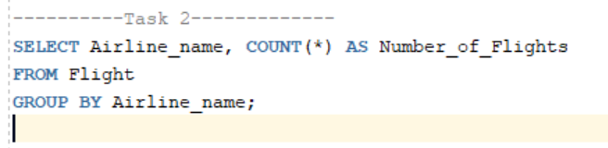

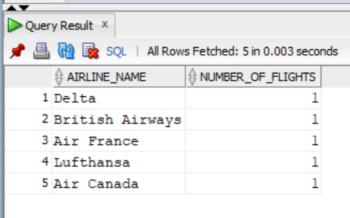Output: